**上机实验3**

**学号**：202030310091 **姓名**：张焕煜 **班级**：电自2005

**一 程序代码：**

#include<iostream>

#include<string>

using namespace std;

class Score{

public:

Score()

{ s=2; }

Score(int s1)

{ s=s1; }

void InputNameAndScore()

{

int i;

for(i=0;i<s;i++)

{

cout<<"请输入学生姓名:"<<endl;

cin>>Name[i];

cout<<"请输入科目A成绩:"<<endl;

cin>>SScore[i][1];

cout<<"请输入科目B成绩:"<<endl;

cin>>SScore[i][2];

cout<<"请输入科目C成绩:"<<endl;

cin>>SScore[i][3];

}

}

void ShowNameAndScore()

{

int i;

for(i=0;i<s;i++)

{

cout<<"姓名: "<<Name[i]<<" 科目A成绩: "<<SScore[i][1]<<" 科目B成绩 "<<SScore[i][2]<<" 科目C成绩: "<<SScore[i][3]<<endl;

}

}

void ShowStdentAvgScore(int a)

{

float avg = 0;

avg = (SScore[a][1]+SScore[a][2]+SScore[a][3])/3;

cout<<"姓名: "<<Name[a]<<" 平均成绩: "<<avg<<endl;

}

void ShowClassAvgScore(string ClassName)

{

int b;

float avg = 0;

if(ClassName == "A") b = 1;

if(ClassName == "B") b = 2;

if(ClassName == "C") b = 3;

for(int i=0;i<s;i++)

{ avg = avg + SScore[i][b]; }

avg = avg/s;

cout<<"课程名称: "<<ClassName<<"平均成绩: "<<avg<<endl;

}

void OrderScore(string ClassName)

{

int b;

if(ClassName == "A") b = 1;

if(ClassName == "B") b = 2;

if(ClassName == "C") b = 3;

for(int i=0;i<s;i++)

{

SScore1[i] = SScore[i][b];

}

for(int i=0;i<s;i++)

{

Name1[i] = Name[i];

}

for(int i=1;i<s;i++)

{ if(SScore1[i] > SScore1[i-1])

{ float temp = SScore1[i-1];

SScore1[i-1] = SScore1[i];

SScore1[i] = temp;

string temp1;

temp1 = Name1[i-1];

Name1[i-1] = Name1[i];

Name1[i]= temp1;

}

}

cout<<"课程(由高到低排序): "<<ClassName<<endl;

for(int i=0;i<s;i++)

{

cout<<"姓名: "<<Name1[i]<<" 成绩: "<<SScore1[i]<<endl;

}

}

private:

float SScore[100][3],SScore1[100];

string Name[100],Name1[100];

int s;

};

int main()

{ Score S;

S.InputNameAndScore();

S.ShowNameAndScore();

S.ShowStdentAvgScore(0);

S.ShowStdentAvgScore(1);

S.ShowClassAvgScore("A");

S.OrderScore("A");

S.ShowClassAvgScore("B");

S.OrderScore("B");

S.ShowClassAvgScore("C");

S.OrderScore("C");

return 0;

}

**二 程序结果：**

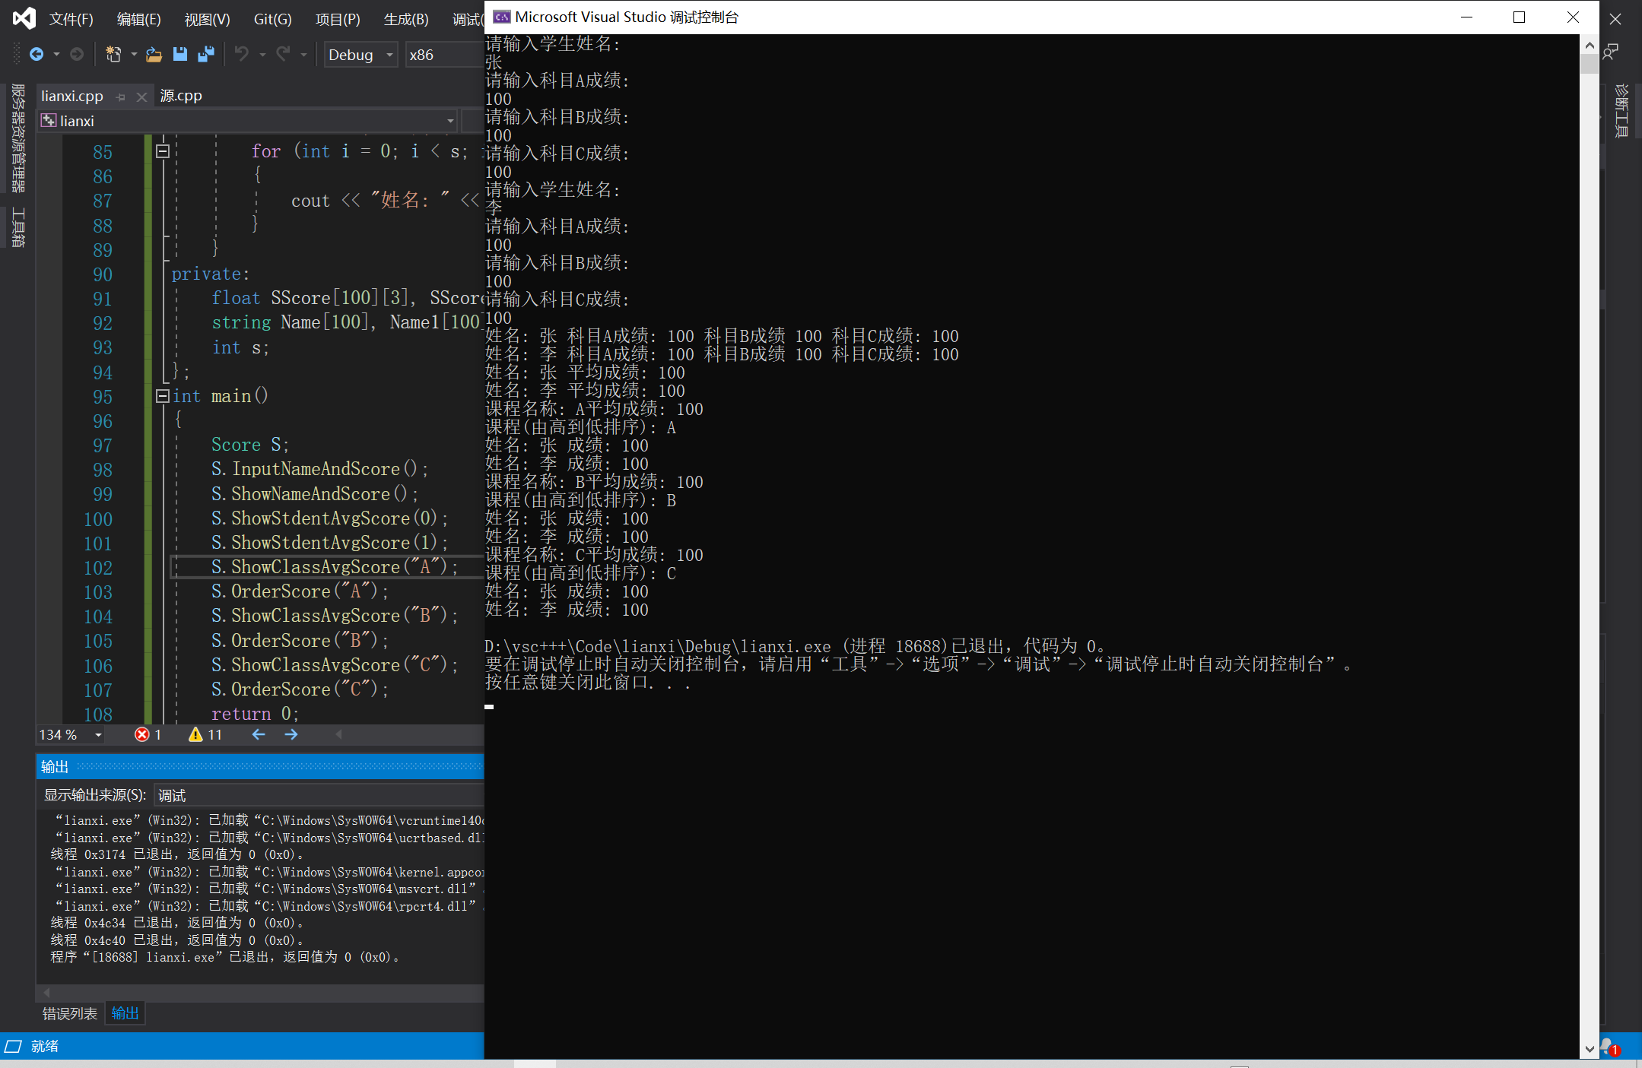

**三 感想心得:**

初步感觉到c++的难了，代码比C语言难写，但是更好用。